Artificial Intelligence Final Report Assignment 問題3 (Problem 3)

レポート解答用紙 (Report Answer Sheet)

Group Leader

学生証番号 (Student ID): 20521180

名前(Name): Trương Quốc Đạt

Group Members

学生証番号 (Student ID): 20521729

名前(Name): Nguyễn Triệu Kim Oanh

学生証番号 (Student ID): 20521714

名前(Name): Nguyễn Phan Uyển Nhi

学生証番号 (Student ID): 20521505

名前(Name): Trần Ngô Tuấn Kiệt

問題3 (Problem 3)のレポート

### Program

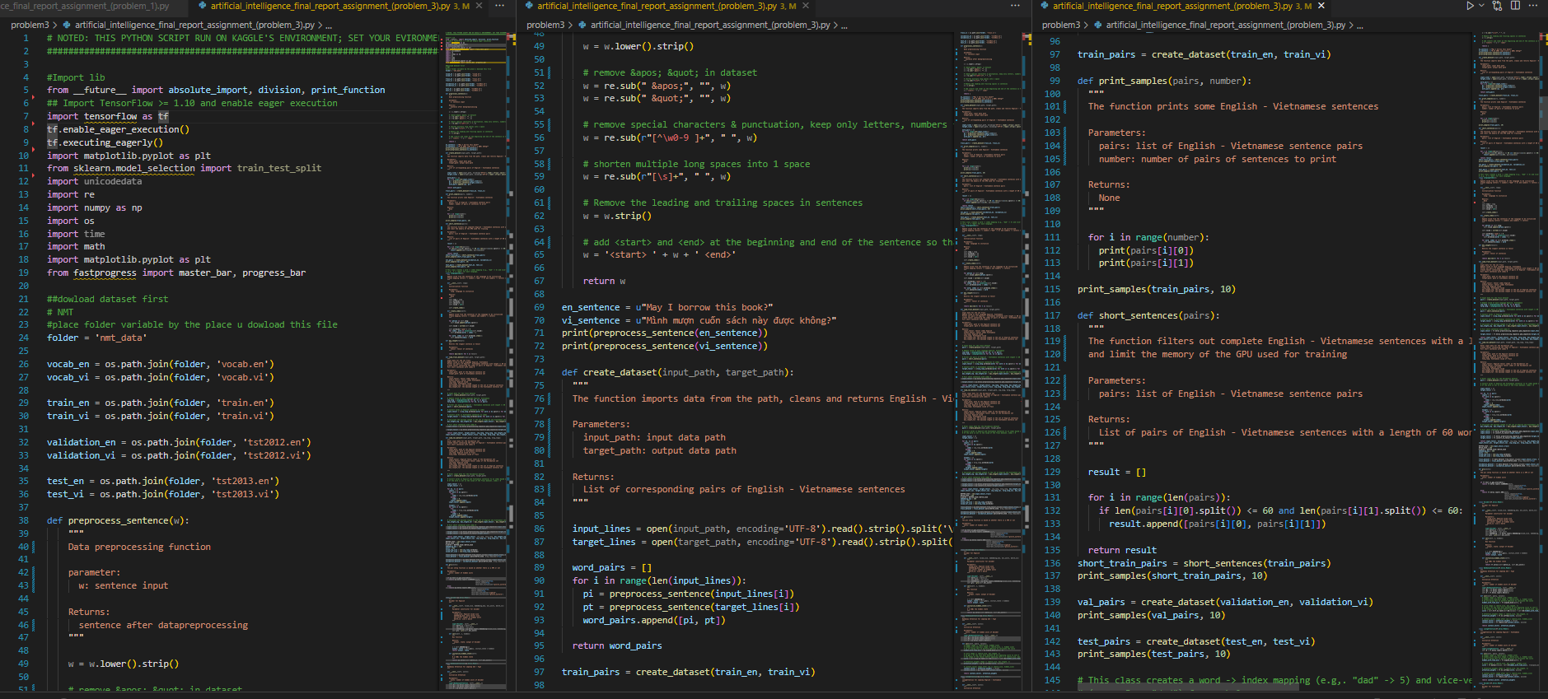

### Execution Results

**Loss in each epoch:**

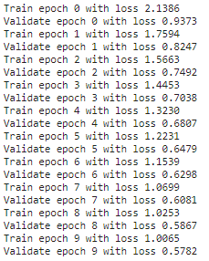

**Average Bleu Score in Test dataset:**

### Explanation

**Preprocessing dataset:**

* Remove &apos; &quot; in dataset.
* Remove special characters & punctuation, keep only letters, numbers from 0-9 and spaces.
* Shorten multiple long spaces into 1 space.
* Remove the leading and trailing spaces in sentences.
* Add <start> and <end> at the beginning and end of the sentence so that the model knows where to start and end the prediction.
* Create index: Update vocab from the sentences of the language to be initialized
* Create mapping letters -> numbers and numbers -> letters

**Parameter Tuning:**

* BUFFER_SIZE
* BATCH_SIZE = 256
* N_BATCH = BUFFER_SIZE//BATCH_SIZE
* embedding_dim = 256
* units = 512
* vocab_inp_size
* vocab_tar_size

**Encode, decode**

**Attention:**

* BahdanauAttention
* LuongAttention